# CS 340 Project Two README

## About the Project/Project Title

The title of the project is Project Two Web Application Dashboard. The objective of this project is to create a functional Python web application dashboard to make the viewing of the data from a separate MongoDB database easier using Dash and a Python “middleware” interface. The interface is meant to streamline CRUD operations between the MongoDB database and the Python dashboard to let the user quickly and easily access information about dogs available to train for a variety of different rescue operations.

## Motivation

The motivation for this project is to make things simpler and more appropriate while querying the Mongo Database. The project is implemented by executing the Python script to run the Mongo server and create an easy-to-use web dashboard for the client. They Want to easily sort through the large list of animals and find what dogs would be suitable for them.

## Getting Started

The first real step to getting the project to work is setting the appropriate credentials in the __init__

method of the class and that the database you want to manipulate is imported properly. The database

utilizes authentication thus the requirement for credentials. After that, you need to make sure that the

“middleware” interface is located in the same directory as the Python dashboard. Then, it’s just a

matter of setting up the dashboard using Python and the Dash framework. The database used in the

examples is a database of animals from the Austin Animal Center (AAC).

## Installation

The tools used for this project were, Python code created in Jupyter Notebook which utilizes libraries for Pymongo, Dash which is the framework used to create the Python dashboard, and an admin user for the database in the terminal to be able to interact with MongoDB.

## Usage

This project allows the user to filter all the information within the MongoDB database into specified categories and view it as an easier-to-understand list while providing them with a visual graph of the information. It does this by using Python code to create this functionality to interact with the MongoDB to make it easier for the user to utilize and provides them with a map and pie graph to help them understand the information provided.

### Code Example

The code was written in Python using Jupyter Notebook. It imports from the Mongo client and gives the user access to the database within MongoDB to read the information and separate by their selected filer in Jupyter Notebook. You can see how this is done in the screenshots below.

### Tests

The tests are executed by first making a test script with .py file, and later running that file in

Python. The test executed will create a new entry into the database, read the database and display it to the user, update a specific entry in the database, and finally delete a specific entry from the database as we can see in the screenshots below.

### Screenshots

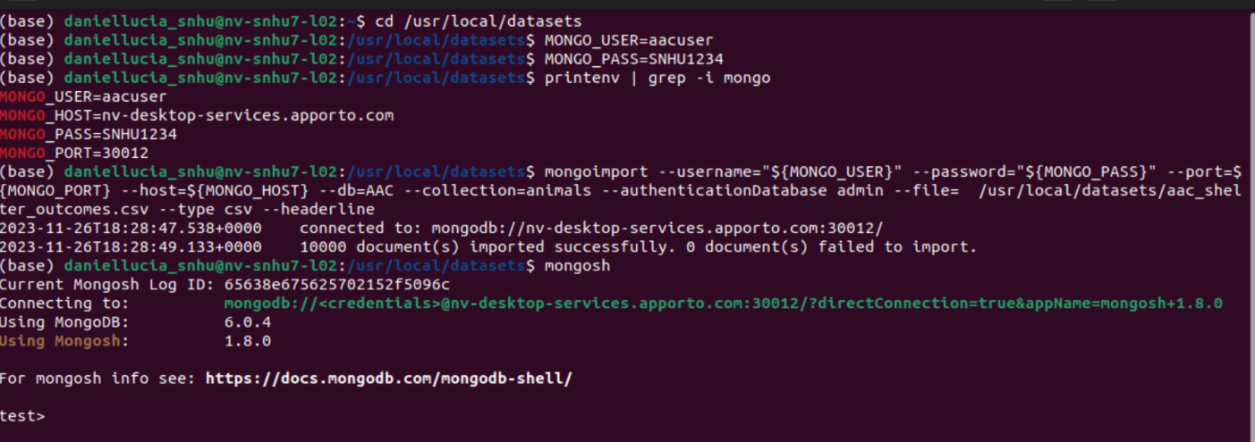

Here we can see the MongoDB database that we are accessing.

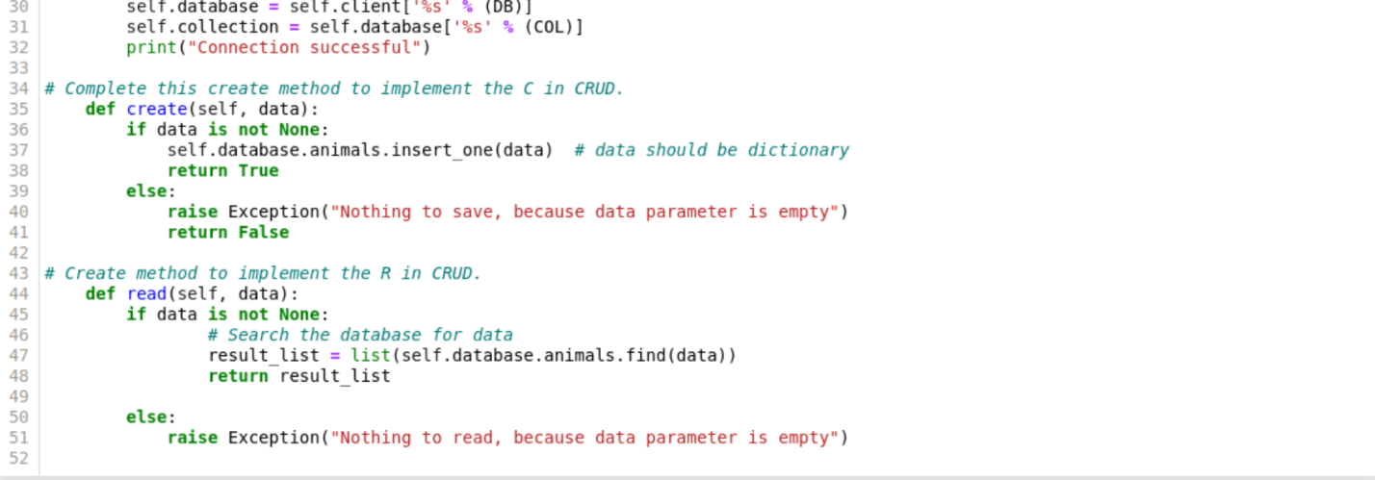

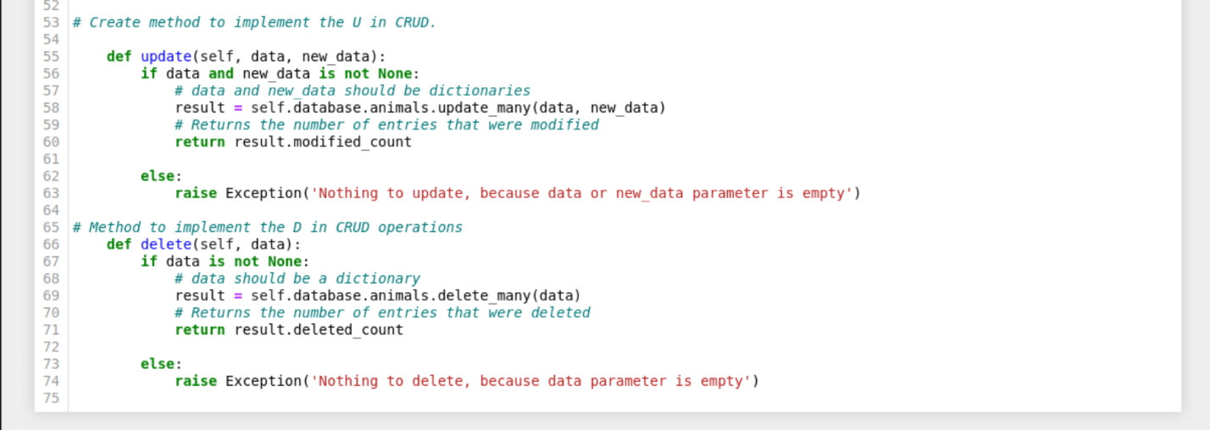

The above screenshots show how the Python code is used to create the CRUD functionality to access and manipulate the MongoDB database.

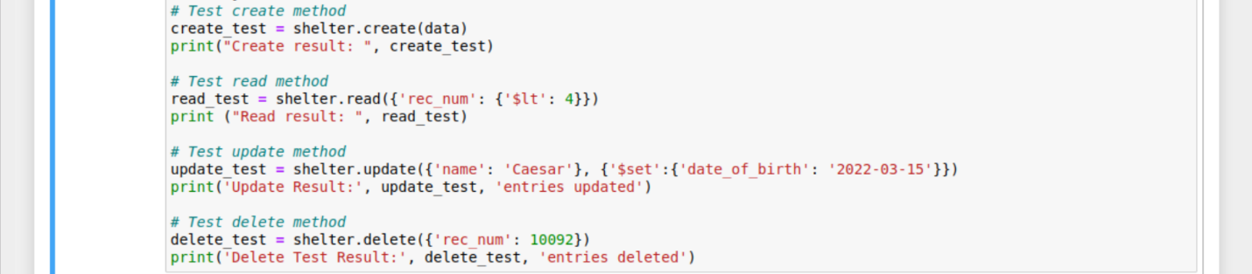

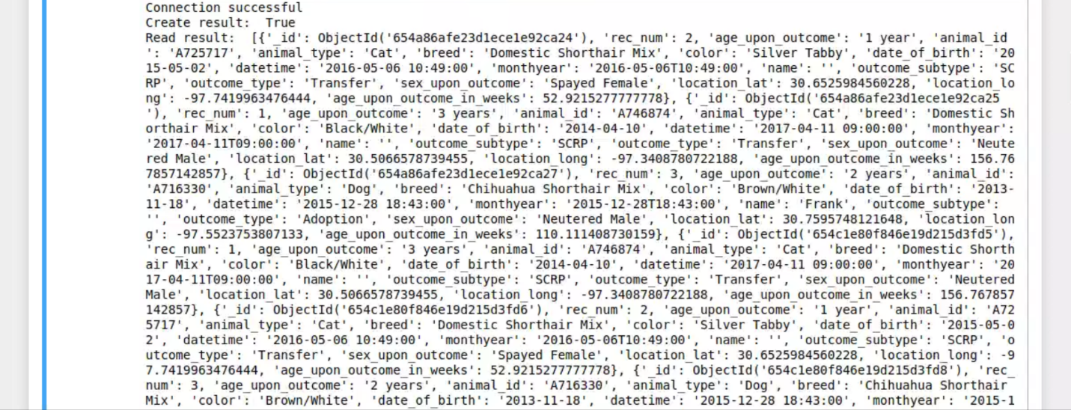

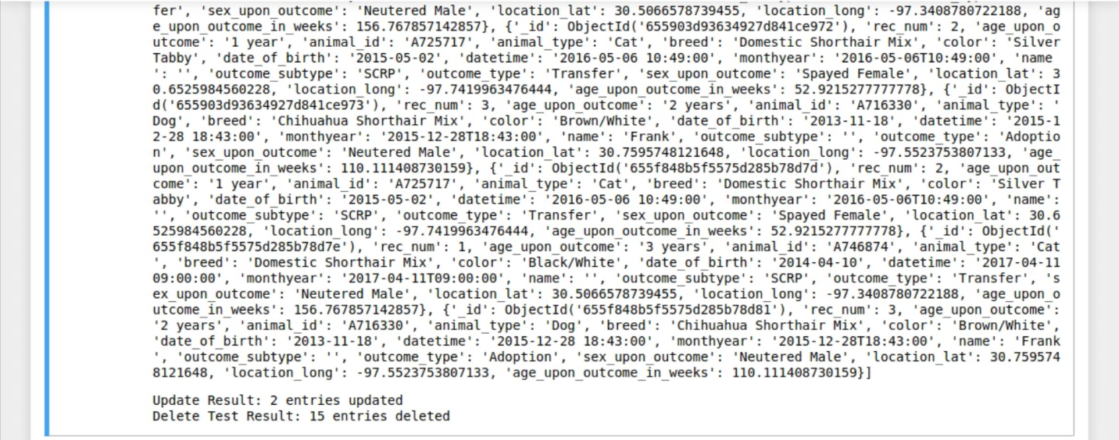

These are the tests I performed to prove the CRUD functionality functions as intended.

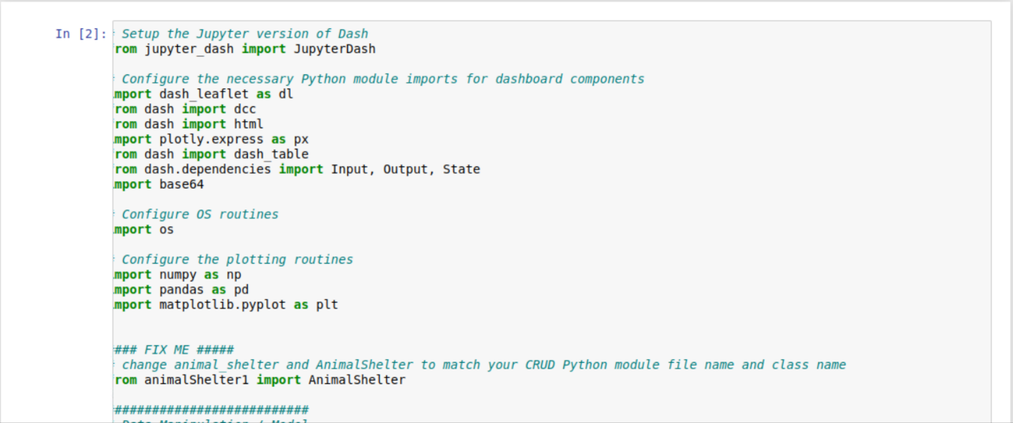

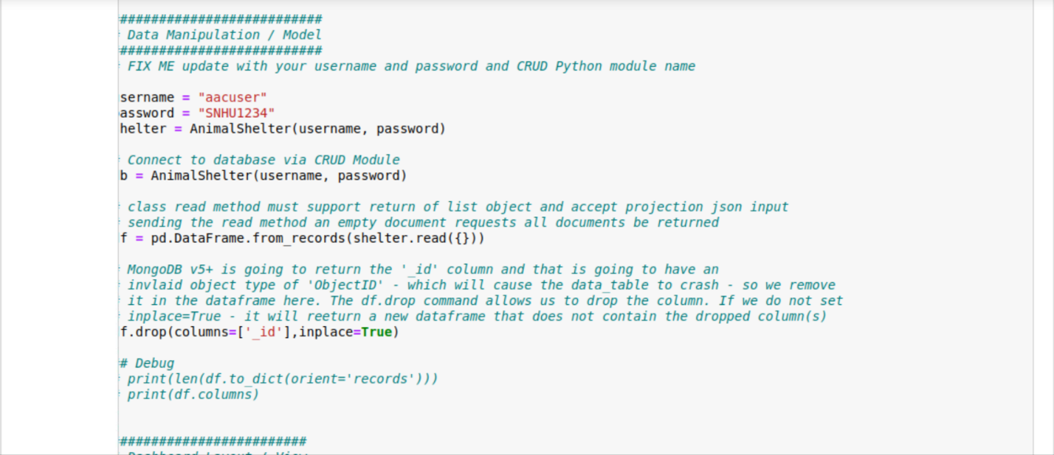

Here is where we added the username and password to the program so it can access the information from the database.

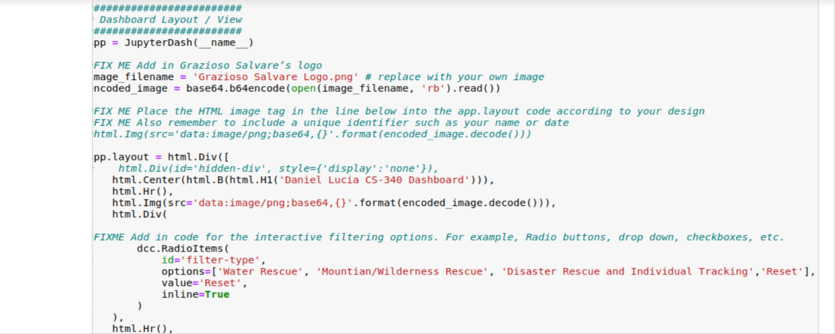

This adds the logo to the program of the clients and the interactive buttons so they can filter the information to their desired options.

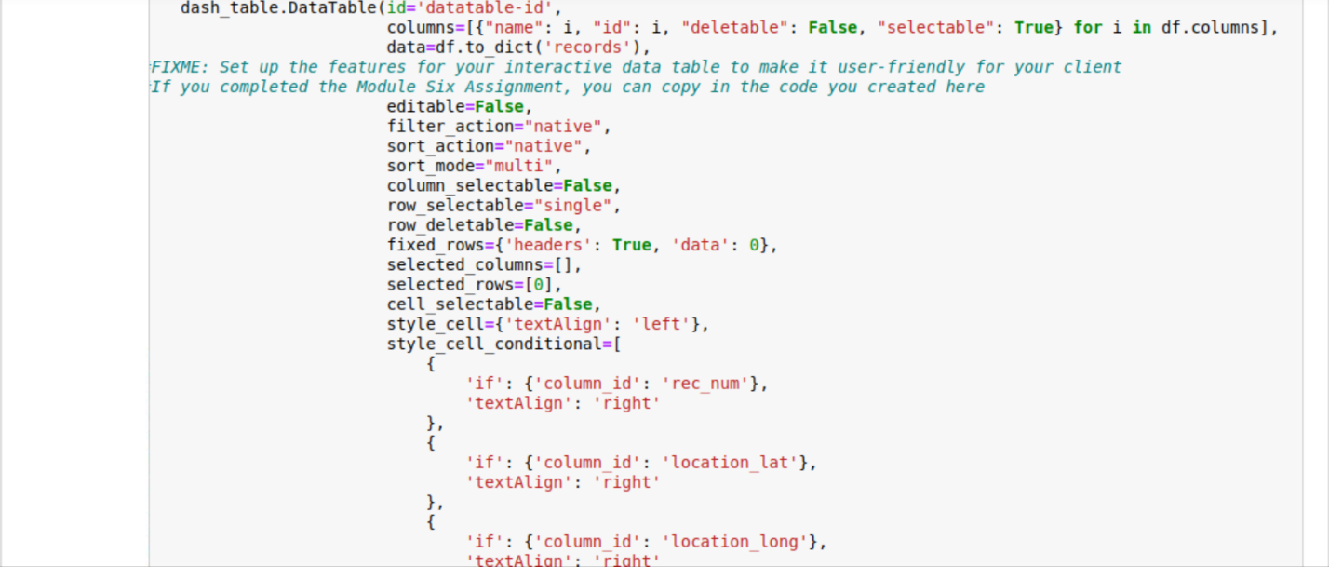

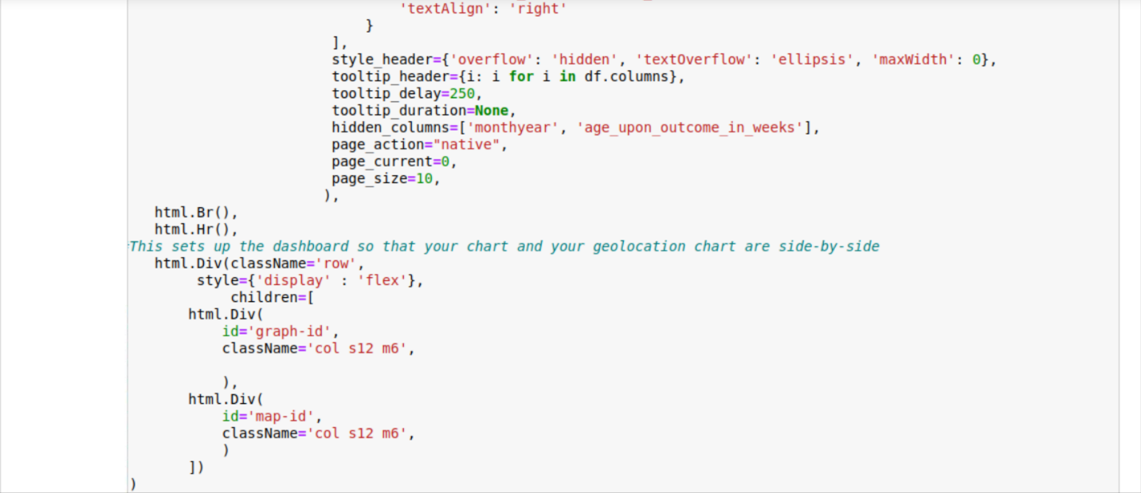

The above screenshots set up how the list will be displayed to the user.

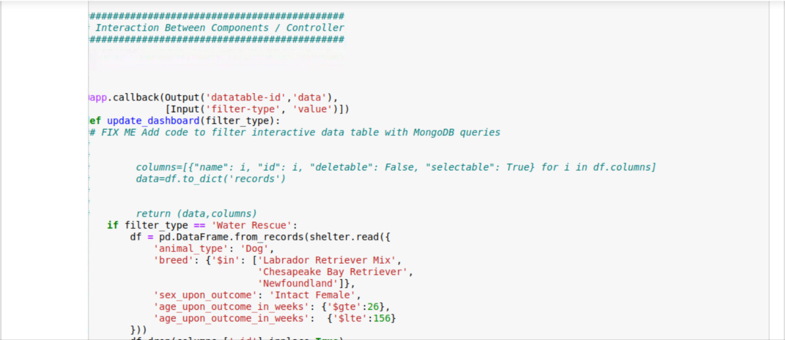



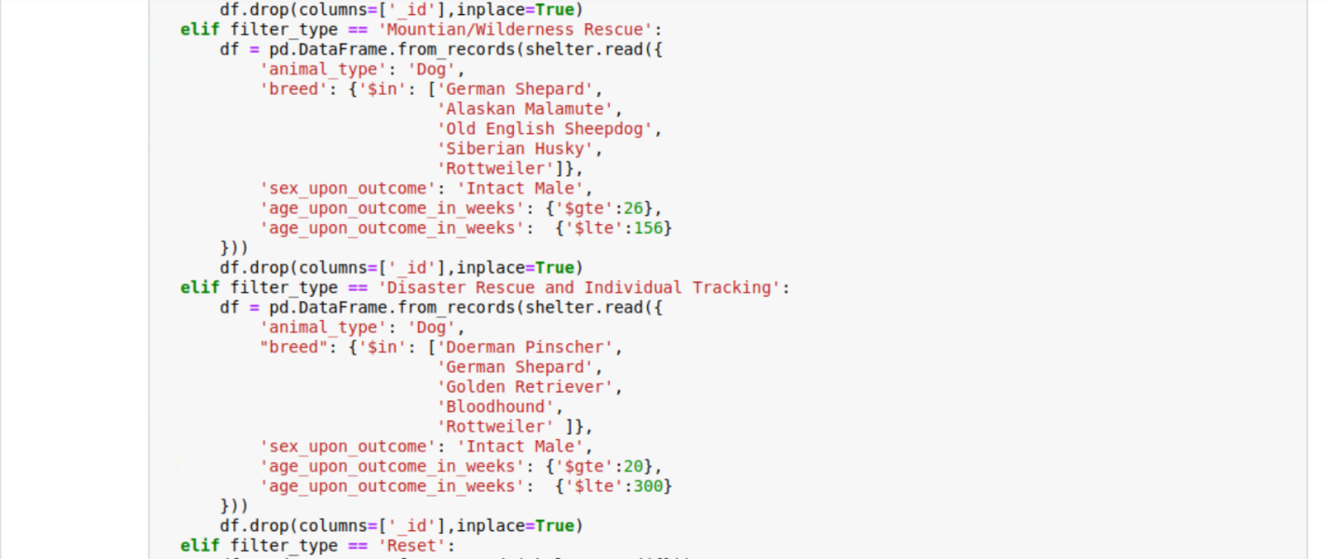

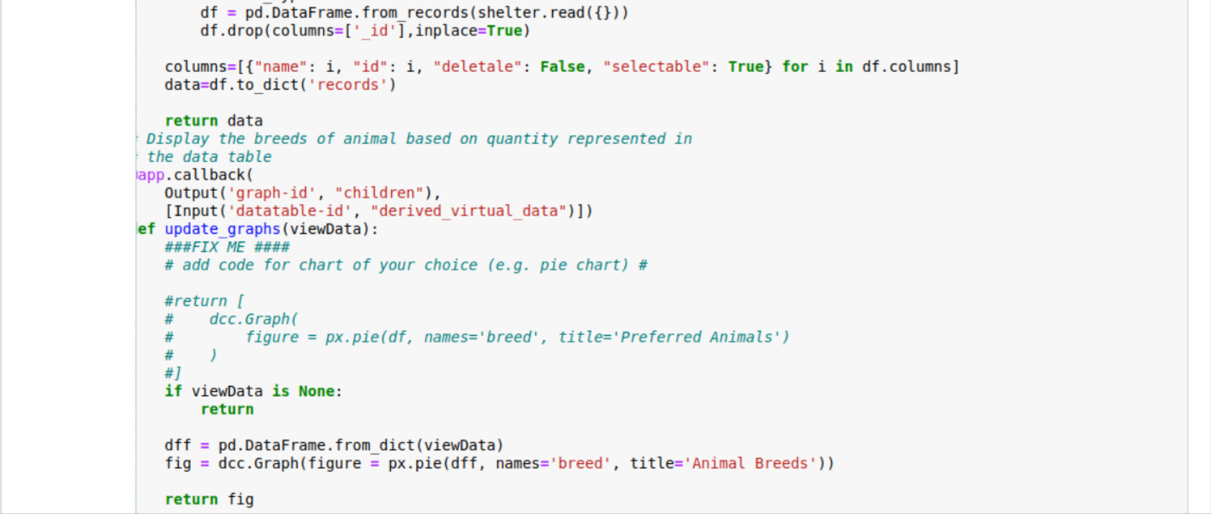

Here is where we set up the filters to the desired options filter out all the unrelated animals and set up the graph to show the new filtered list.

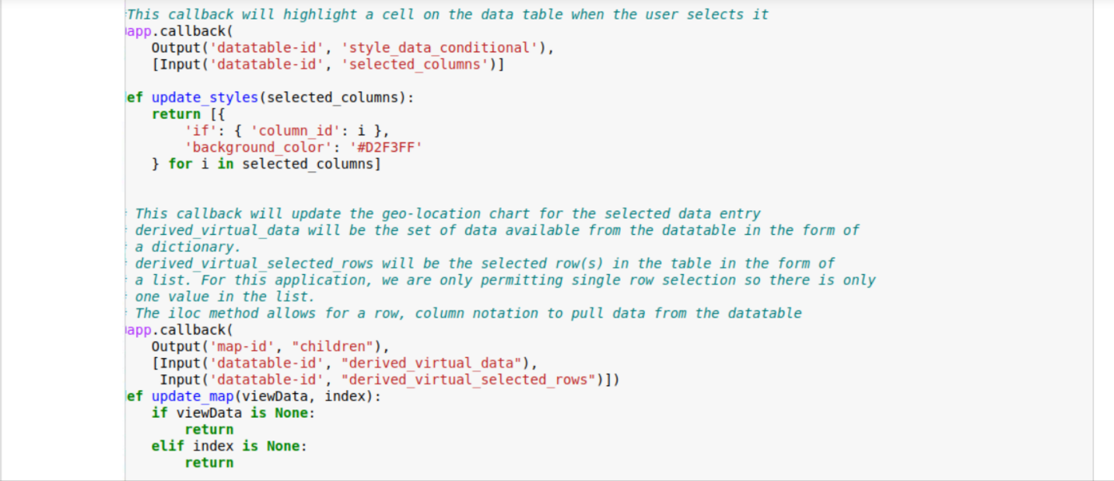

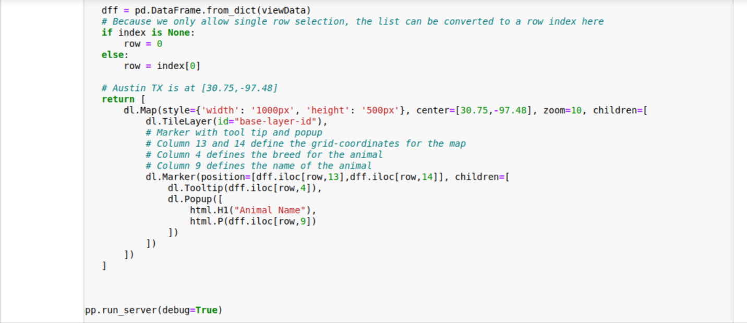

This is where the map is created to display it to the user.

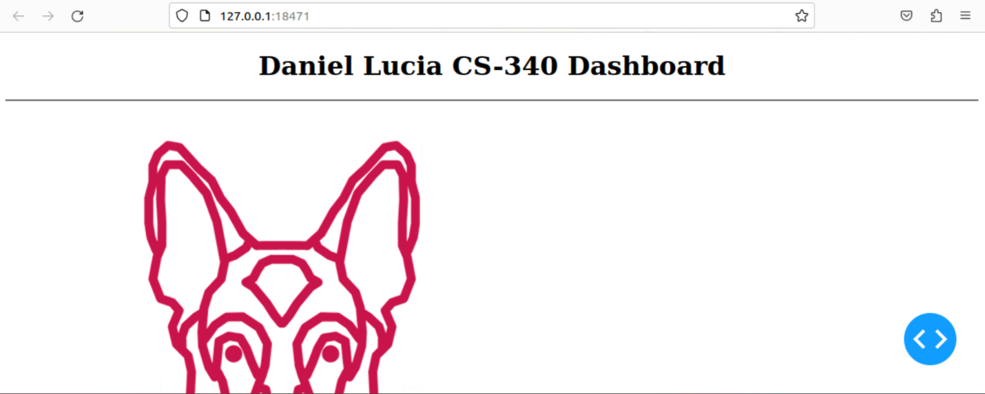

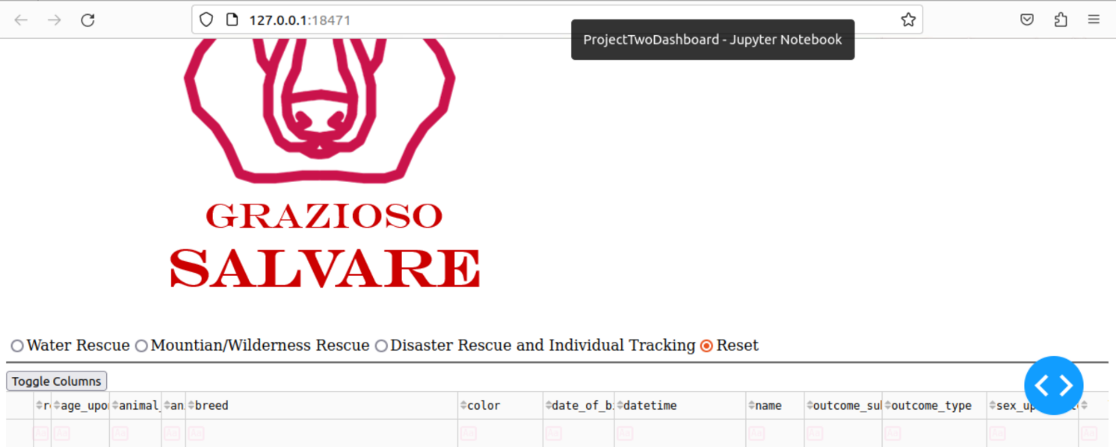

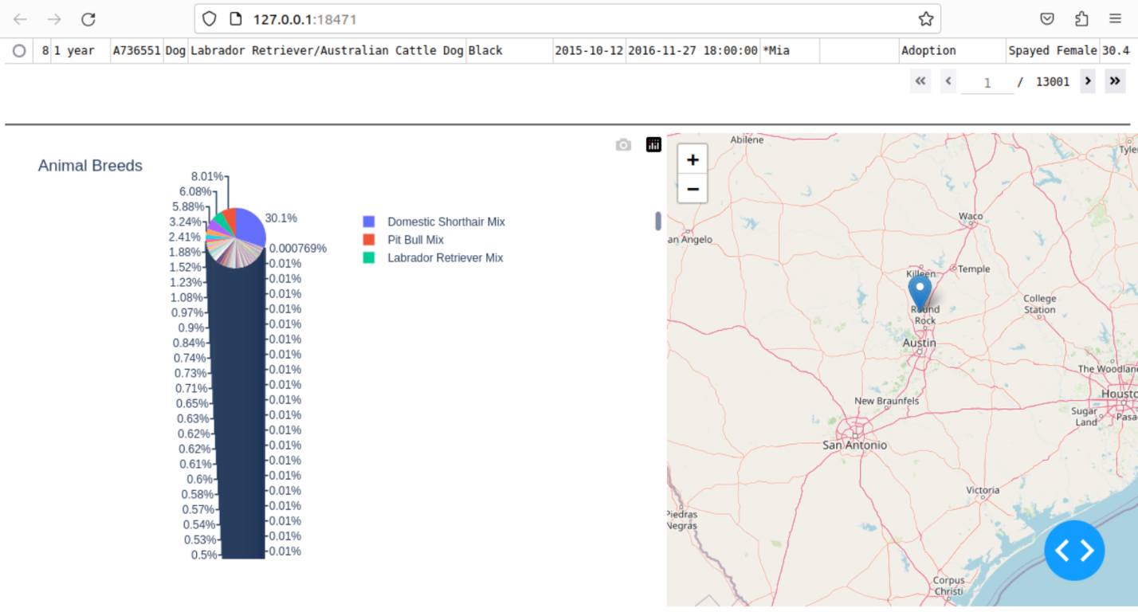

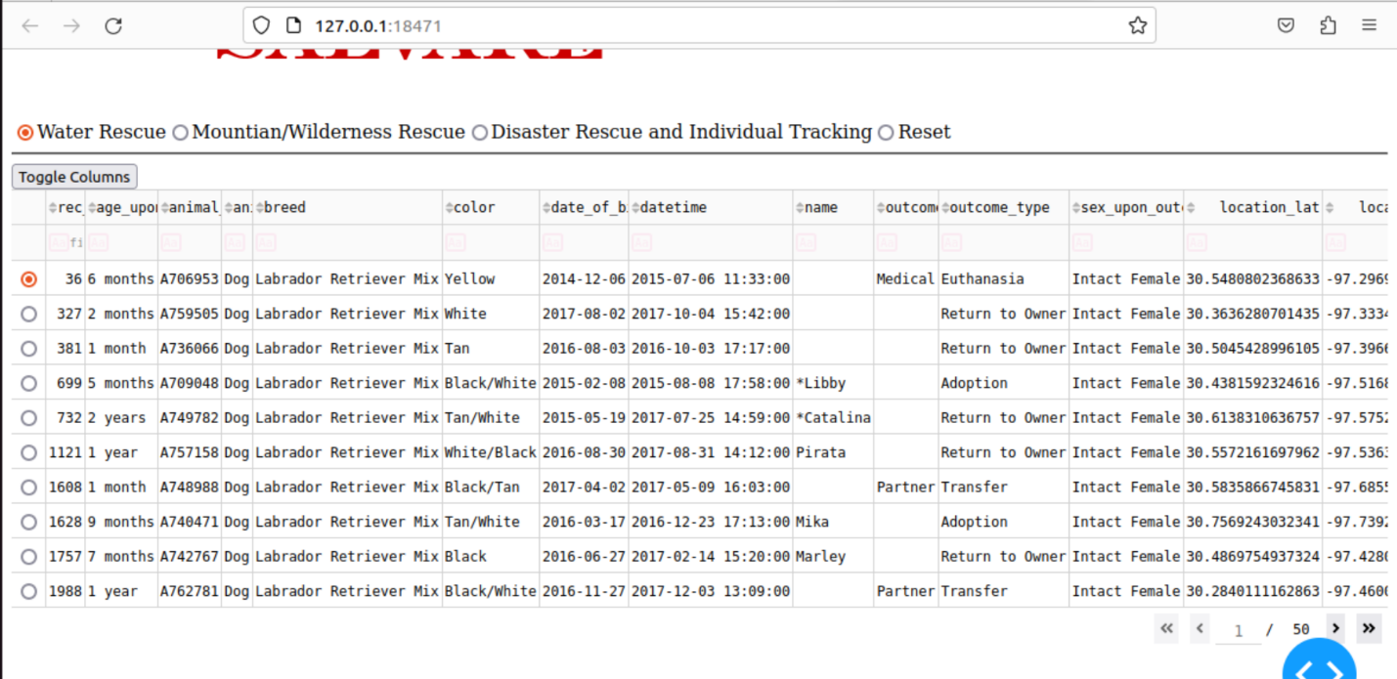

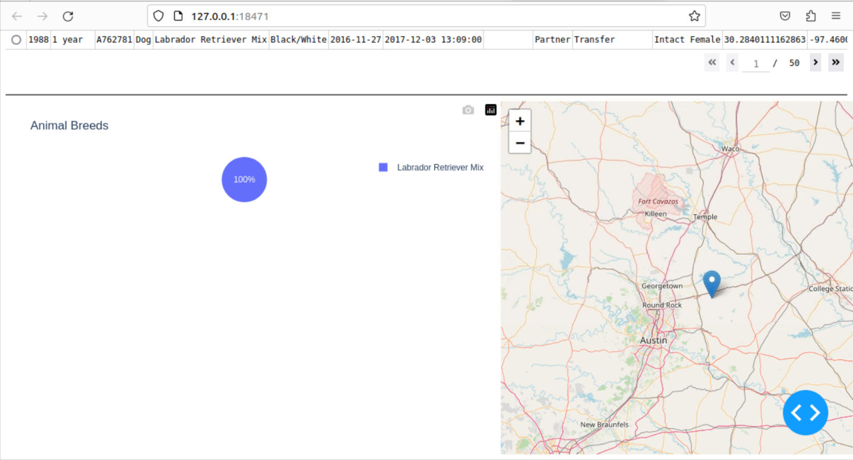

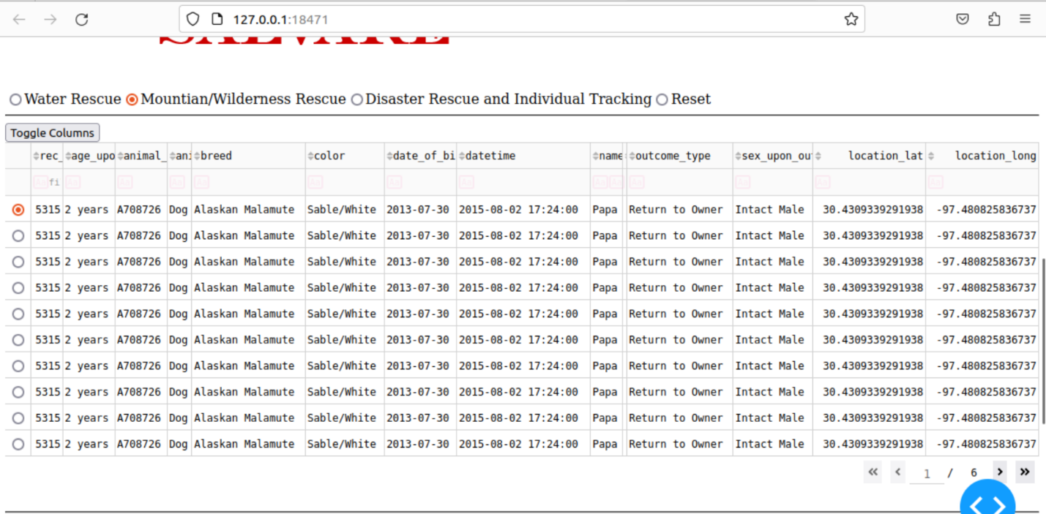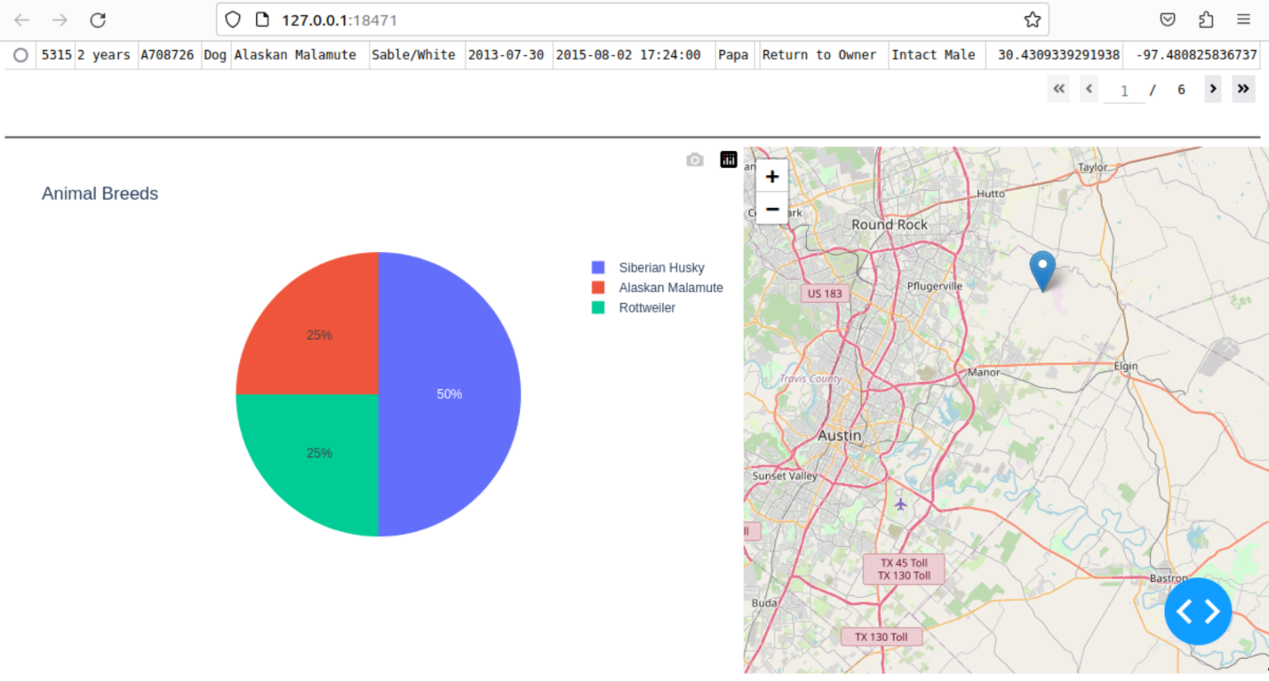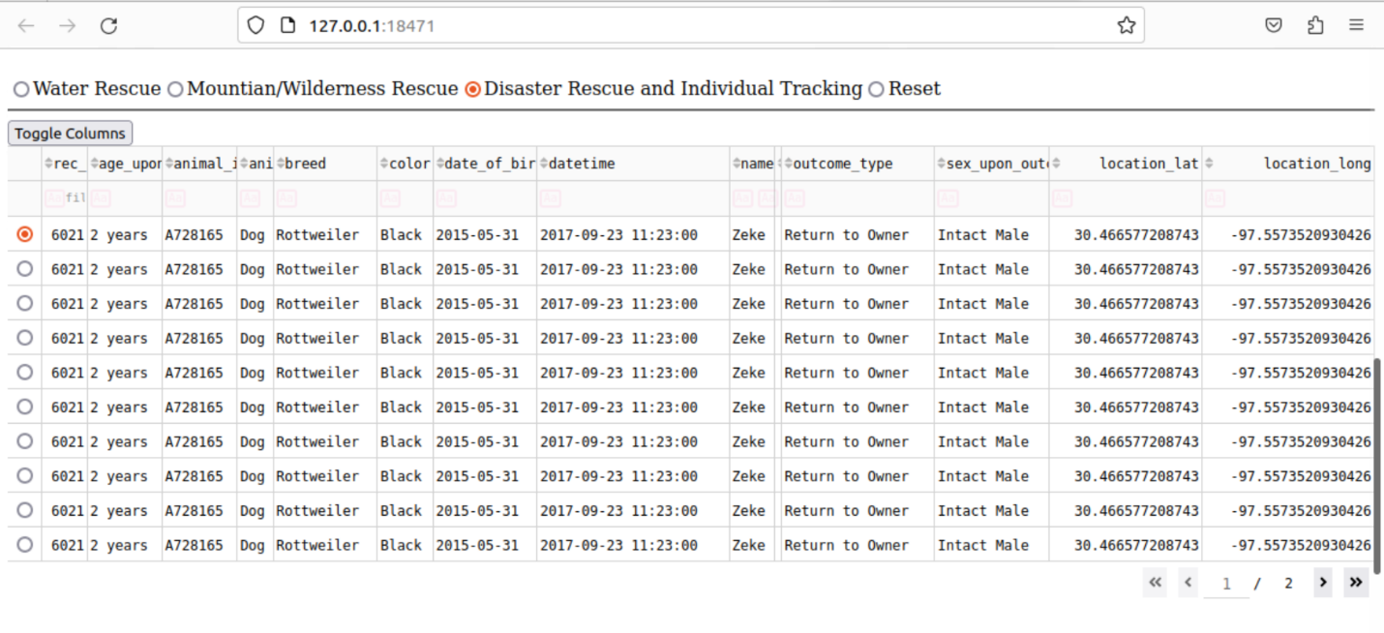

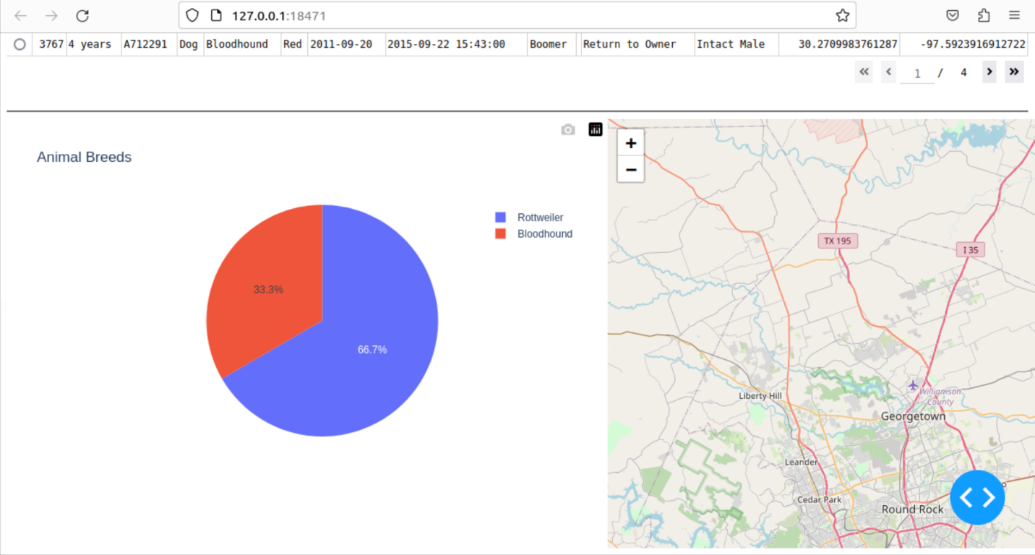

Finally, we have what each filter option will show the user it has the updated list, graph, and map to show each filter that is selected.

## Difficulties

The main difficulty I had was writing the code for the dashboard. The main issue was when I tried to have the graph and map updated for the selected filter. I had accidentally misspelled the mountain and disaster rescue options in the filter type section of the code, and it took me a while to realize that is why it would not update because it was a subtle error that was hard to catch. The other thing that took me a minute to figure out was the proper syntax to implement the radio buttons since that was a new aspect of this project that we had not implemented into any of the previous milestones.

## Contact

Daniel Lucia